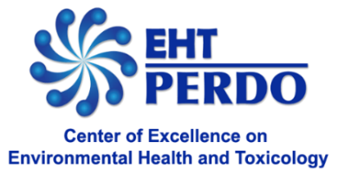
International Conference on
Environmental Pollutants and Toxicants Affecting Health:
Collaborative Efforts for Improving Quality of Life
Organized by the Center of Excellence on Environmental Health and Toxicology
(Program: Hub of Talents in Environmental Health, with support of the National Research Council of Thailand - NRCT)
June 19 - 21, 2024
at the Convention Center, Chulabhorn Research Institute, Bangkok, Thailand

REQUEST FOR A BRIEF BIOGRAPHY
Name: |  | Insert  Photo
Position:
Affiliation:
Country:

Brief Statement (e.g. education, field of interest, and distinction)

Thank you

